SLIYS I - 2018
Summer Linguistics Institute for Youth Scholars

Session 1: June 24-29 Session 2: July 8-13

Instructors: Antonio Hernandez hernandez.413@osu.edu
Elena Vaikšnoraitė vaiksnoraite.1@osu.edu
Resident Assistants: Daniel Puthawala puthawala.1@osu.edu
Kayo Puthawala puthawala.2@osu.edu
Classroom Location: Jennings Hall 140
SLIYS Coordinators: Dr. Julia McGory mcgory.1@osu.edu
Oxley Hall Room 106 1712 Neil Avenue
614-688-3109 cell: 614-725-9217
Gina Ndoci ndoci.1@osu.edu
614-292-4052 cell: 614-316-4603
Department of Linguistics Main Office: www.ling.osu.edu
Oxley Hall
614-292-4052

DORM CHECK IN and ORIENTATION

SUNDAY June 24-Session 1 / July 8-Session 2

Dorm Check In for Dorm Residents – 4-5:30pm Smith-Steeb Hall, located at 80 W. 11th Avenue. https://housing.osu.edu/roomsearch/smith-steeb-hall

The SLIYS staff will meet SLIYS participants in the Smith-Steeb lobby and assist with dorm check-in between 4-5:30pm. After receiving a key, we will help participants take luggage to their dorm room. After check-in, all participants and SLIYS staff will meet for orientation and this includes pizza, salad, games, and a tour of campus.

Dormitories:
SLIYS All Sessions: Smith-Steeb Hall, located at 80 W. 11th Avenue. https://housing.osu.edu/roomsearch/smith-steeb-hall

Orientation for Dorm Residents and Commuters: 5:30-8:30pm
All SLIYS participants are invited to attend an orientation including pizza, salad, and games followed by an OSU campus tour Sunday evening. Commuter parents, please drop your children off at 5:30pm at Smith-Steeb Hall and plan to pick them up around 8:30pm. It’s best to make sure your child has a cell phone if timing of pick up changes slightly.

Drop off and pick up for Check-In & Orientation will be at Smith-Steeb Hall; 80 West 11th St.
https://housing.osu.edu/roomsearch/smith-steeb-hall
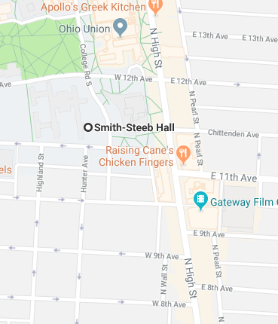

SLIYS CLASSES - Jennings Hall 136
https://www.osu.edu/map/building.php?building=014

DROP OFF 8:50am Monday-Friday morning s– Jennings Hall
Classes are held in Jennings Hall on Neil Avenue. Please drop your child off in front of Jennings Hall each morning. Julia McGory will meet you the first day. She will be wearing a black/white SLIYS t-shirt.

PICK UP 5:00pm – Oxley Hall; 1712 Neil Avenue

https://www.osu.edu/map/building.php?building=102
Please make arrangements with your child for pick up and drop off locations after this first morning

LUNCH: Commuters, please pack a lunch or bring enough cash ($6-$9) to purchase lunch at a local restaurant.
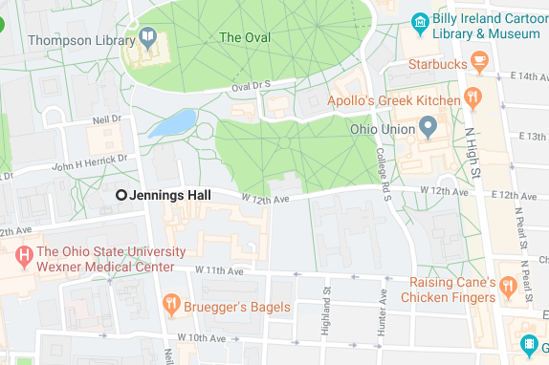

CLASS SCHEDULE Classroom Location: Jennings Hall; rm. 136

MONDAY

Morning Session: Jennings Hall; rm 136
8:00-9:00 Residents: Meet for breakfast in dorm lobby with RAs/SLIYS staff
8:50 Commuters: Drop off (Dr. McGory will meet you at Jennings Hall- see drop off location on above map.)
9:00-10:30 Session 1: What is linguistics? What is linguistic field work? (Linguistics)
10:30-12:00 Session 2: The Sounds of Language: Consonants (Phonetics)
*12:00-1:00 Lunch with students (Introduction to campus area)
1:00-1:45 Language Activity: “The Linguists”
1:45-2:15 Language Group Focus: Consonant Bingo
2:15-2:30 Walk to Linguistics Department at Oxley Hall

Afternoon Session: Computer Lab – Department of Linguistics – Oxley Hall
2:30-5:00 Tour of the Department of Linguistics
Meet with Language Consultants
Preparation for Poster Session
5:00 Commuters: Pick up
**6:00 Group Dinner at:
Apollo's Greek Kitchen
1758 N. High St. Columbus OH, 43201
(614) 294-4006

Meet in the common area in Dormitory
**Commuters are encouraged to come. Please bring $10.00.

TUESDAY
8:00-9:00 Residents: Breakfast in dorms or local restaurants with RAs

Morning Session: Jennings Hall; rm 136
8:50 Commuters: Drop off (students go to classroom on their own)
9:00-10:30 Session 1: The Sounds of Language: Vowels (Phonetics)
10:30-10:45 Break
10:45-12:15 Session 2: Race, Ethnicity, Gender, Sexuality, and Language (Sociolinguistics)
*12:15-1:15 Lunch
1:15-2:15 Language Activity: IPA Trivia
2:15-2:45 Language Group Focus: Sounds of Language and Phonemic Inventory

Afternoon Session: Computer Lab – Department of Linguistics – Oxley Hall
2:45-3:00 Break (Walk to Linguistics Department)
3:00-5:00 Native Speaker Consultation
5:00 Pick up (commuters)
**6:30 Movie Night-Gateway Theater
Meet in the common area in Dormitory

WEDNESDAY
8:00-9:00 Residents: Breakfast in dorms or local restaurants with RAs

Morning Session: Jennings Hall; rm 136
8:50 Commuters: Drop off
9:00-10:30 Session 1: Parts of Words and Sentences (Morphology and Syntax)
10:30-10:45 Break
10:45-12:15 Session 2: Guest Speaker – Dr. Julia Papke (topic TBA)
*12:15-1:15 Lunch: Tour of Thompson Library. Lunch in a nearby location (bring cash, sac-lunch, or Buck-ID)
1:15-2:15 Language Activity: Tree-building Game
2:15-2:45 Language Group Focus: Morphology and Syntax across languages

Afternoon Session: Computer Lab – Department of Linguistics – Oxley Hall
2:45-3:00 Break
3:00-5:00 Native Speaker Consultation
5:00 Pick up (commuters)
5:00-6:30 Dinner
**7:00 Game night. Meet in the common area in Dormitory

THURSDAY
8:00-9:00 Residents: Breakfast in dorms or local restaurants with RAs

Morning Session: Jennings Hall; rm 136
8:50 Commuters: Drop off
9:00-10:30 Session 1: Discovering Linguistic Meaning (LF Semantics)
10:30-10:45 Break
10:45-12:15 Session 2: Guest Speaker Assistant Professor Micha Elsner (topic TBA)
*12:15-1:15 Lunch
1:15-2:15 Language Activity: Meaning in Context
2:15-2:45 Language Group Focus: Semantics

Afternoon Session: Computer Lab – Department of Linguistics – Oxley Hall 2:45-3:00 Break
3:00-5:00 Native Speaker Consultation
5:00 Pick up (commuters)
5:00-6:00 Dinner
**6:30 RPAC- Recreation & Physical Activity Center recsports.osu.edu
Meet in the common area in Dormitory

FRIDAY
8:00-8:30 Residents: Breakfast in dorms or local restaurants with RAs

Morning Session: Department of Linguistics - Oxley Hall
8:35am Bus transport to COSI, downtown Columbus
Meet outside of Smith-Steeb Hall for bus pick up. (Commuters – please let instructors know if you are planning on taking bus or will be dropped off by parents.)
9:15-11:15 Language and the Mind (Psycholinguistics) (Led by Ellen Dossey)
COSI Pod
11:15 Meet outside of COSI- for bus transportation to OSU Campus.

Afternoon Session: Computer Lab – Department of Linguistics – Oxley Hall
12:00-2:30 Working lunch (Linguistics Department) - Final preparations for presentations
2:30-3:30 Poster set-up
3:30 Family Arrival (parking information will be emailed)
4:00-5:00 Poster Presentations and Closing Ceremony: Jennings Hall 60
Visitor Parking is at the Ohio Union Parking Garage on High Street.

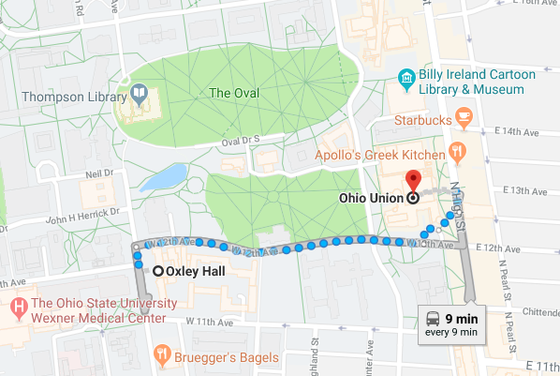

DEPARTURE & CHECKOUT ---- FRIDAY
5:00 All commuters and dorm residents should be picked up at this time if not attending the closing ceremonies.
Dorm residents will need to go to dorms at this time to collect personal items and leave keys with dorm director.

*Lunch: Dorm residents will be provided Buck ID cards which they can use at local restaurants. Commuters may either bring their lunch or $6-9.00 to purchase lunch at a local restaurant.

**Evening Events: All commuters are encouraged to join us for the evening events. These will start at different times each evening and times and locations will be announced the day of or the day before the event.

Please contact Kayo Puthawala (773-993-7043); puthawala.2@osu.edu) to ensure that the SLIYS staff are aware that your child is attending the evening activity.

