SLIYS II: A SECOND SLIYS - 2018
Summer Linguistics Institute for Youth Scholars
July 15-20

Instructors: Antonio Hernandez hernandez.413@osu.edu
Elena Vaikšnoraitė vaiksnoraite.1@osu.edu
Resident Assistants: Daniel Puthawala puthawala.1@osu.edu
Kayo Puthawala puthawala.2@osu.edu
Riley Wagner wagner.1068@osu.edu
Classroom Location: Jennings Hall 140
SLIYS Coordinators: Dr. Julia McGory mcgory.1@osu.edu
Oxley Hall Room 106 1712 Neil Avenue
614-688-3109 cell: 614-725-9217
Gina Ndoci ndoci.1@osu.edu
Department of Linguistics Main Office: www.ling.osu.edu
Oxley Hall 1712 Neil Avenue
614-292-4052

DORM CHECK IN and ORIENTATION
SUNDAY, July 15, 2018

Dorm Check In for Dorm Residents – 4-5:30pm Smith-Steeb Hall, located at 80 W. 11th Avenue. https://housing.osu.edu/roomsearch/smith-steeb-hall

The SLIYS staff will meet SLIYS participants in the Smith-Steeb lobby and assist with dorm check-in between 4-5:30pm. After receiving a key, we will help participants take luggage to their dorm room. After check-in, all participants and SLIYS staff will meet for orientation and this includes pizza, salad, games, and a tour of campus.

Dormitory: Smith-Steeb Hall, located at 80 W. 11th Avenue. https://housing.osu.edu/roomsearch/smith-steeb-hall

Orientation for Dorm Residents and Commuters: 5:30-8:30pm
All SLIYS participants are invited to attend an orientation including a meal and games Sunday evening.
Commuter parents, please drop your children off at 5:30pm at Smith-Steeb Hall and plan to pick them up around 8:30pm. Make sure your child has a cell phone if timing of pick up changes slightly.

Drop off and pick up for Check-In & Orientation will be at Smith-Steeb Hall;

https://housing.osu.edu/roomsearch/smith-steeb-hall

80 West 11th Street, 43210
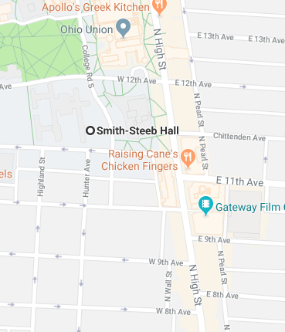

SLIYS CLASSES -
Morning Session: Jennings Hall 136
https://www.osu.edu/map/building.php?building=014

Afternoon Session: Oxley Hall; 1712 Neil Avenue

https://www.osu.edu/map/building.php?building=102

DROP OFF 8:50am Monday-Friday mornings– Jennings Hall; 1735 Neil Ave, Columbus OH, 43210

Please drop your child off in front of Jennings Hall each morning.

PICK UP 5:00pm – Oxley Hall; 1712 Neil Avenue, Columbus OH, 43210

https://www.osu.edu/map/building.php?building=102
Please make arrangements with your child for pick up and drop off locations after this first morning

LUNCH: Commuters, please pack a lunch or bring enough cash ($6-$9) to purchase lunch at a local restaurant.

1712 Neil Avenue
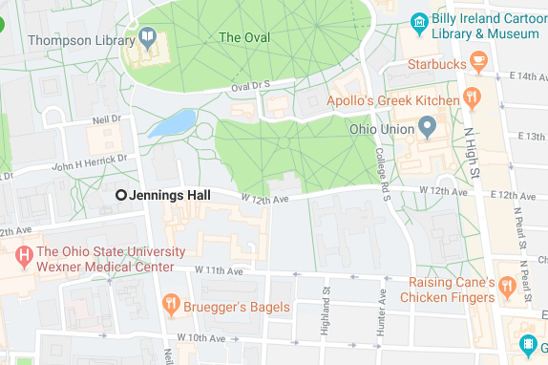
CLASS SCHEDULE Classroom Location: 136 Jennings Hall

MONDAY
8:00-9:00 Residents: Meet for breakfast in dorm lobby with RAs/SLIYS staff

Morning Session: 136 Jennings Hall
8:50 Commuters: Drop off in front of Jennings Hall.
9:00-10:30 Session 1: Allophones, Phonemes, and Accents
10:30-10:45 Break
10:45-12:15 Session 2: Rule-based Phonology
*12:15-1:15 Lunch
1:15-2:15 Session 3: Historical Phonology
2:15-2:45 Activity: Sound Change Data Set
Afternoon Session: Computer Lab – Department of Linguistics – Oxley Hall
2:45-3:00 Walk to Linguistics Department – Oxley Hall (across the street from Jennings Hall)
3:00-5:00 Consultants: Sound Processes in Target Language
5:00 Commuters: Pick up (Location to have been determined with parent)
**6:00 Group Dinner at TBA
Meet in the common area in dormitory
(Commuters are welcome. Please bring $10.00.)

TUESDAY
8:00-9:00 Residents: Breakfast in dorms with RAs/SLIYS staff

Morning Session: Jennings Hall; rm 136
8:50 Commuters: Drop-off (students go to classroom on their own)
9:00-10:00 Session 4: Phonology – Phonotactics and Loan Word Adaptation
10:00-10:15 Break
10:15-12:00 Activity: Choose Your Sound Change
12:00-1:00 Lunch
1:00-2:00 Session 5: Language Classification and Models of Language Change
Afternoon Session: Computer Lab – Department of Linguistics – Oxley Hall 2:15-3:00 Activity: Adapted Loan Word List
3:00-5:00 Consultants: Check for loan words and how they’re adapted
5:00 Pick up (commuters)
**6:30 Movie Night-Gateway Theater
Meet in the common area in dormitory

WEDNESDAY
8:00-9:00 Residents: Breakfast in dorms with RAs/SLIYS staff
8:50 Commuters: Drop off
9:00-10:30 Session 6: Syntactic Variation (Micro-/Macrovariation and Null Subject)
10:30-10:45 Break
10:45-12:00 Session 7: Analogy and Semantic Change
12:00-1:00 Lunch
1:00-2:15 Activity: Incoherent Passage
2:15-2:30 Break

Afternoon Session: Computer Lab – Department of Linguistics – Oxley Hall
2:30-3:00 Language Group Focus: Eliciting Syntactic Phenomena
3:00-5:00 Consultant
5:00 Pick up (commuters)
5:00-6:30 Dinner
**7:00 Game night. Meet in the common area in dormitory

THURSDAY
8:00-9:00 Residents: Breakfast in dorms with RAs/SLIYS staff
8:50 Commuters: Drop off
9:00-10:30 Activity: What’s your word for this?
10:30-10:45 Break
10:45-12:15 Session 8: Guest Speaker – Dr. Julia Papke on Constructed Languages
*12:15-1:15 Lunch
1:15-2:45 Session 9: Deixis

Afternoon Session: Computer Lab – Department of Linguistics – Oxley Hall
3:00-5:00 Consultants: Eliciting Deixis
5:00 Pick up (commuters)
5:00-6:00 Dinner
**6:30 TBA-Movie night in the dorm w/ sleeping bag

FRIDAY
8:00-8:30 Residents: Breakfast in dorms with RAs/SLIYS staff
8:50 Commuters drop-off
9:00-10:15 Session 10: Language Endangerment
10:30-10:45 Break
10:45-12:20 Activity: We Still Live Here
12:20-1:15 Lunch

Afternoon Session: Computer Lab – Department of Linguistics – Oxley Hall
1:15-3:15 Power Point Preparations
3:00 Family Arrival (parking information will be emailed)
3:30-5:00 PowerPoint Presentations, Closing Ceremony and Departure – Oxley Hall
Please park in the Ohio Union Garage on High Street. Then walk down 12th Avenue to 1712 Neil Avenue.
1712 Neil Avenue
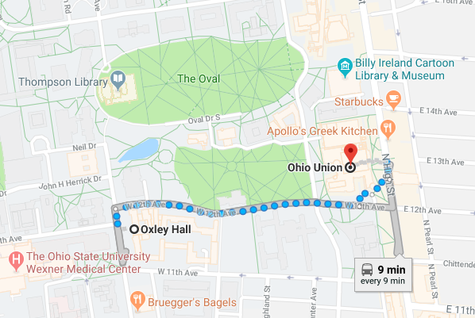

DEPARTURE & CHECKOUT ---- FRIDAY
5:00 All commuters and dorm residents should be picked up at this time if not attending the closing ceremonies.
Dorm residents will need to go to dorms at this time to collect personal items and leave keys with dorm director.

*Lunch: Dorm residents will be provided Buck ID cards which they can use at local restaurants. Commuters may either bring their lunch or $7-$10.00 to purchase lunch at a local restaurant.

**Evening Events: All commuters are encouraged to join us for the evening events. These will start at different times each evening and times and locations will be announced the day of or the day before the event.

Please contact Kayo Puthawala (puthawala.2@osu.edu) (773-993-7043) to ensure that the SLIYS staff are aware that your child is attending the evening activity.

